WEEK 3 DELIVERABLE
Interactive Dashboard & Insight Report
DePaul University Admissions Analytics

Excelerate Data Visualisation trainee | June 2026
Tools: Power BI | Dataset: Excelerate_Cleaned_data.xlsx

Section 1: Dashboard Design Documentation

1.1 Dashboard Overview
This report documents the design, structure, and analytical choices behind an interactive single-page Power BI dashboard built to communicate key admissions insights from the DePaul University applicant dataset. The dashboard covers 5,000 unique applicants across 42 countries, spanning the intake periods from May 2023 to June 2025.

1.2 Dashboard Layout & Structure
The dashboard follows a top-down information hierarchy designed for executive-level readability and analyst-level drill-down:

Zone | Content
Row 1 — Top bar | Dashboard title, subtitle, and 3 interactive slicers (Application Source, Year, Nationality)
Row 2 — KPI Strip | 4 KPI cards: Total Applicants (5,000), Admitted Count (3,256), Evaluation Completed - (2K) Count of country(96)
Row 3 — Primary Charts | Line graph (bimonthly admission trend) + Donut chart (application source split)
Row 4 — Secondary Charts | Bar chart (top courses) + Bar chart (nationalities) + Bar chart (counselor workload)
Row 5 — Detail Table | Full-width drill-down table: Country, Intake Course, Outcome, Counselor, Admit Date

1.3 Visualization Components — Why Each Was Included

Visual | Purpose & Key Insight | Fields Used
Bar Chart(Nationality) | Identifies top applicant-sending countries. India's 53.7% dominance and Ghana/Nigeria's low admit rates are immediately visible, guiding targeted counselor deployment. | student_nationality, DISTINCTCOUNT(Reference_ID)
Bar Chart(Counselor Workload) | Exposes the severe workload imbalance Jagdeep handles 70.2% of all contacts despite 4 counselors being available. Critical for capacity planning. | Caller_Name, Total Applicants
Line Graph(Bimonthly Trend) | Reveals seasonal admission peaks (Jan–Feb, Sept–Oct) enabling proactive staffing. Shows 70% year-over-year growth from 2023 to 2024. | Admit_Date (bimonthly), Admitted Count
Donut Chart(App Source) | Compares Study Group vs Non Study Group split. Study Group is only 15.8% of volume but achieves 83.6% admit rate vs 61.7% a critical quality vs quantity story. | Application_Source, Total Applicants
Table(Country/Intake/Outcome) | Provides analyst-level drill-down. Filtered by Outcome = Missing Transcript, it instantly generates a counselor action list of 957 applicants. | student_nationality, intake_course, Outcome_1, Caller_Name, Admit_Date
Bar Chart(Top Courses) | Highlights Business Analytics (844) and Computer Science (606) as dominant programs together 29% of all applicants justifying dedicated program-specific counseling. | intake_course, Total Applicants

1.4 Slicers & Filters — Interactivity Design

Three slicers were added to enable dynamic, multi-dimensional filtering across all dashboard visuals simultaneously:

Slicer | Field | Analytical Purpose
Application Source Slicer | Application_Source | Isolates Study Group vs Non Study Group to compare admit rates (83.6% vs 61.7%) and justify the partnership ROI.
Year Slicer | Admit_Date (Year) | Enables year-over-year comparison — selecting 2024 shows the peak year with 1,667 admissions, a 70% growth from 2023.
Nationality Slicer | student_nationality | Drills into country-level performance. Selecting Ghana (26.5% admit rate) vs India (77.5%) reveals the transcripts bottleneck for African markets.

1.5 Data Flow & Interactivity Features
The dashboard is built on a single flat table (Cleaned Data ) with 7,543 rows de-duplicated to 5,000 unique applicants via DISTINCTCOUNT on Reference_ID. The data flow operates as follows:

- Raw data (Excel) is loaded via Power Query with Reference_ID converted to Text type to enable DISTINCTCOUNT.
- Five DAX measures are computed: Total Applicants, Admitted Count, Admit Rate %, Missing Transcripts, and Study Group Count.
- All visuals share the same data model slicers apply cross-filtering to every visual simultaneously with no manual interaction configuration required.
- The table visual includes conditional formatting on Outcome_1: amber for Missing Transcript, blue for Follow Up, red for Issue IDs enabling instant status identification.
- Clicking any bar, donut segment, or data point cross-filters all other visuals, enabling multi-dimensional analysis from a single page.

Section 2: Insight Report

The following insights were derived directly from the interactive dashboard, using the 5,000 unique applicant records spanning May 2023 to June 2025. Each insight is linked to a specific dashboard visual and supported by data-driven evidence.

2.1 Key Trends, Patterns & Relationships

Insight 1 | Geography & Nationality — Bar Chart (Top Nationality)
► India dominates with 53.7% of all applicants (2,684 out of 5,000) and maintains a strong 77.5% admit rate making it the highest-ROI recruitment market by both volume and conversion.
► Ghana (412) and Nigeria (361) together contribute 773 applicants (15.5%) the second largest bloc yet Ghana's admit rate is only 26.5%, revealing a significant documentation bottleneck, not a disqualification issue.
► Bangladesh (40%) and Nepal (46.8%) show high applicant volume with critically low admit rates, indicating systemic transcript and ID verification challenges in South Asian markets beyond India.
► Top city globally: Hyderabad with 570 applicants exceeding all US cities combined, confirming that city-level targeting within India would yield high recruitment efficiency.
Recommendation: Run targeted transcript follow-up campaigns for Ghana, Nigeria, Bangladesh, and Nepal. These markets are losing admits to documentation gaps, not academic shortcomings. A document-readiness webinar per country could unlock hundreds of pending admits.

Insight 2 | Counselor Workload — Clustered Bar Chart (Counselor)
► Jagdeep handles 70.2% of all counselor contacts (1,260 out of 1,806 tracked cases) a severe single point of failure. If Jagdeep is unavailable for any period, 70% of the active pipeline stalls.
► All counselors demonstrate near-perfect admit rates: Jagdeep 97.1%, Swarna 99.7%, Ayesha 100%, Lavnaya 100% confirming that quality is not the issue; capacity distribution is.
► Ayesha and Lavnaya together handle only 240 cases (13.3%) despite 100% admit rates. Their underutilization represents a direct loss of counseling capacity that could be deployed immediately.
► Swarna handles 306 cases with a 99.7% admit rate and has demonstrated capacity for additional caseload without quality degradation.
Recommendation: Immediately redistribute a minimum of 400 cases from Jagdeep to Ayesha and Lavnaya. Hire 1-2 additional counselors specifically for the Ghana and Nigeria pipeline, which currently lacks any dedicated counselor coverage.

Insight 3 | Admission Trends — Line Graph (Bimonthly)
► Admissions peak consistently in January-February each year: Feb 2024 recorded the single highest month (245 admits), followed by Jan 2025 (224) and Oct 2023 (238). Two clear intake seasons exist: Jan-Feb and Sept-Oct.
► Summer months (June-August) show consistent dips to 80-99 admissions per month — representing a natural window for backlog clearance and transcript follow-up rather than new recruitment.
► 2024 was the strongest year with 1,667 admissions — a 70% year-over-year growth from 2023 (983). The 2025 trajectory based on Jan-Mar data suggests similar or higher performance if counselor capacity is maintained.
► The bimonthly view reveals that growth is not linear — it comes in defined waves aligned to academic intake calendars, enabling predictive resource planning.
Recommendation: Scale counselor capacity proactively every December-January and August-September to handle intake peaks. Redirect counselor energy toward transcript resolution and backlog clearance during June-August slow months each year.

Insight 4 | Application Source — Donut Chart
► Study Group applicants achieve an 83.6% admit rate versus only 61.7% for Non Study Group applicants — a 35% performance advantage despite representing only 15.8% of total volume (788 vs 4,212).
► Every 10 Study Group applicants yields 8.4 admits, compared to 6.2 admits per 10 Non Study Group applicants — demonstrating measurably superior pipeline efficiency through the Study Group channel.
► Non Study Group dominates volume (84.2%) but requires significantly more counselor effort per successful admit, representing the primary workload burden on counselors like Jagdeep.
► The Study Group partnership appears highly concentrated in certain nationality segments; expanding it to underperforming markets like Ghana and Bangladesh could directly improve those countries' admit rates.
Recommendation: Expand the Study Group partnership to Ghana, Nigeria, and Bangladesh where Non Study Group admit rates are critically low. Apply Study Group pre-screening criteria to Non Study Group applicants to improve their conversion rate from 61.7% toward the 83.6% benchmark.

2.2 How Insights Support Data-Driven Decision Making

Each insight from this dashboard directly informs one of three decision domains requested in the brief:

Decision Domain | Dashboard Evidence | Action Enabled
Recruitment Targeting | India 53.7% of applicants, Hyderabad top city, Ghana/Nigeria low admit rates despite high volume | Focus marketing budget on Hyderabad; deploy document-readiness programs in Ghana and Nigeria
Counselor Engagement | Jagdeep handles 70.2% of caseload; Ayesha and Lavnaya at 100% admit rate but 13.3% of volume | Redistribute caseload immediately; hire 2 counselors for African market; assign Ghana pipeline to underutilized staff
Admission Outcomes | 957 missing transcripts, Study Group 83.6% vs Non SG 61.7%, transcript follow-up dropped to 0 in 2025 | Weekly transcript follow-up protocol; expand Study Group to low-performing markets; revive 2023 transcript receipt process

Section 3: Dashboard Screenshots & Link

3.1 Live Dashboard Link
The interactive Power BI dashboard can be accessed at the following link:

Dashboard Link: https://github.com/samriddhi1901/Excelerate/blob/main/excelerate%20Admission%20Visualisation.pbix

3.2 Screenshot Guide
The following screenshots demonstrate the dashboard functionality and key interactivity features. Each screenshot is taken with a different slicer combination to highlight a specific analytical story:

Screenshot 1: Full Dashboard — No Filters Applied

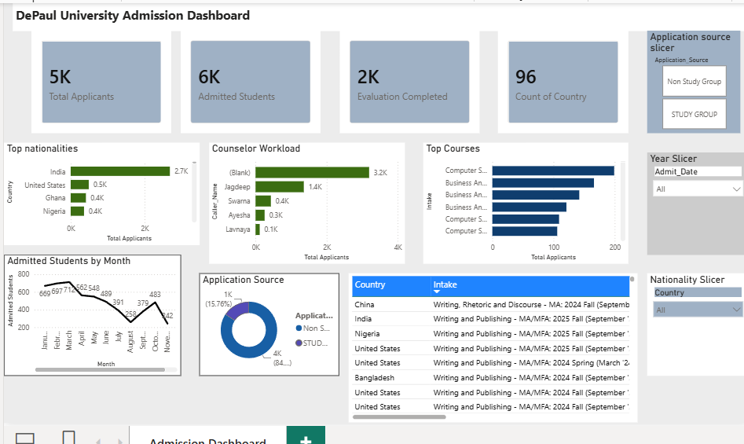
Description: Default view showing all 5,000 applicants. KPI cards display: Total = 5,000, Evaluation completed = 2K , Count of country = 96. All charts visible in their unfiltered state.

Screenshot 2: Nationality Filter = India
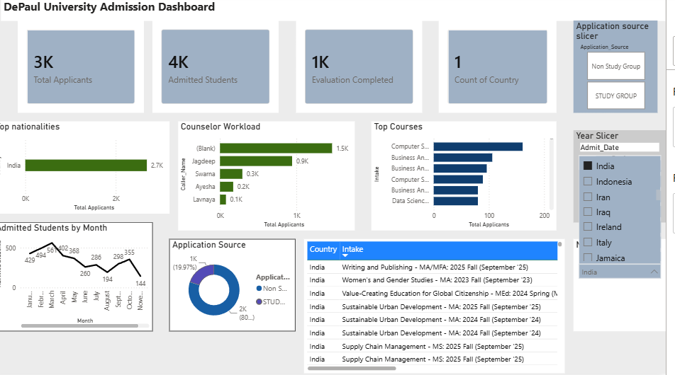
Description: Dashboard filtered to India only (3K applicants,). Shows Business Analytics as top course, Jagdeep as primary counselor, and Missing Transcript as top outcome even for the best-performing market.

Screenshot 3: Nationality Filter = Ghana

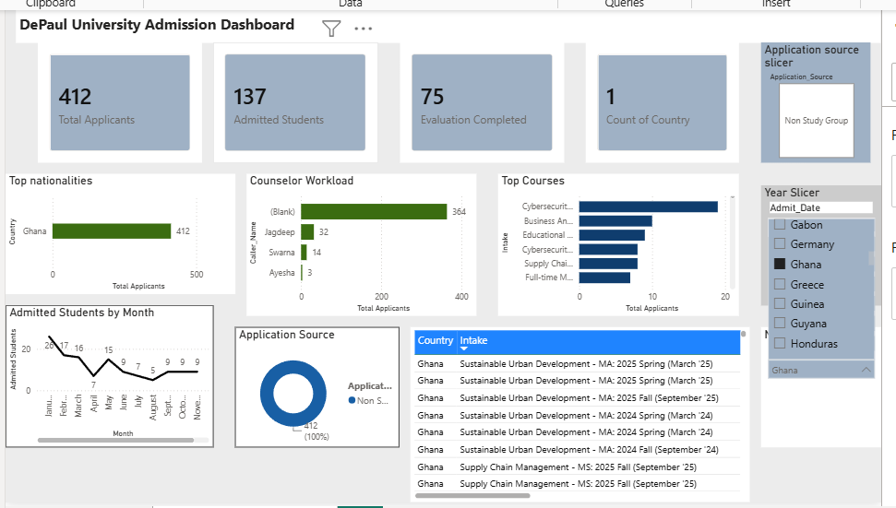
Description: Dashboard filtered to Ghana (412 applicants, 137 admitted students, 75 Evaluation completed) Dramatically lower KPI values. Table view shows Missing Transcript as dominant outcome the bottleneck story in visual form.

Screenshot 4: Source Filter = Study Group

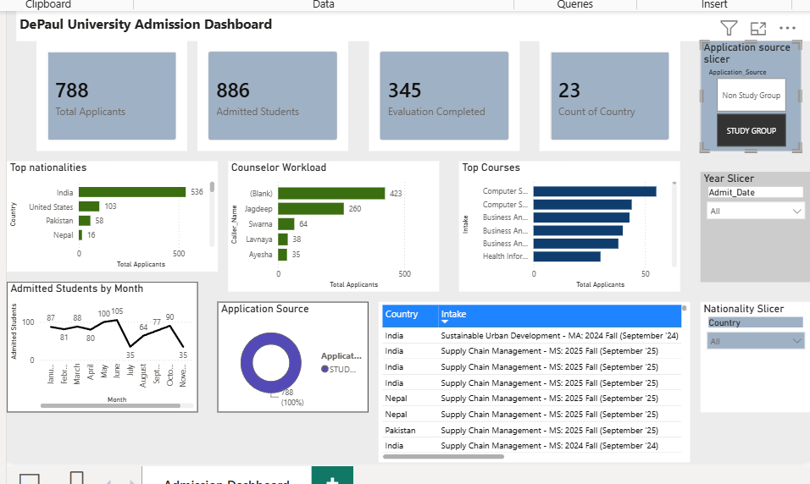
Description: Filtered to Study Group only (788 applicants, 345 Evaluation completed , 23 count of country). It demonstrates the quality advantage of the Study Group.

